Design Report
Kai Lu
1
Project Title: FPGA System for Computer-aided Diagnosis of Cardiac Murmurs
Author: Kai Lu
Abstract: A computer-aided diagnosis (CAD) algorithm was designed and implemented
on an Altera Cyclone II FPGA to detect cardiac murmurs from recorded heart signals.
Training and evaluation data sets were obtained from the online “Classifying Heart
Sounds Challenge” sponsored by PASCAL. The detection algorithm calculates the Low
Energy Rate (LER) from a recorded heart signal and performs a binary classification of
the sample as either normal or murmur. The FPGA system interfaces with a commercial
digital stethoscope to acquire real time data as well as a VGA-compatible monitor for
visualization and metric reporting. In addition, basic I/O was developed for user input to
the system. The result is a complete embedded system capable of acquiring and
analyzing cardiac data in real time to detect heart murmurs.

Design Report
Kai Lu
2
Executive Summary
Cardiac murmurs are pathologic sounds that are produced by turbulent blood
flow in the heart. Detailed diagnoses of pathologic murmurs often require
echocardiogram procedures. Although the procedure is effective, it requires special
equipment and trained technicians to capture the necessary images and
measurements. On the other hand, heart murmurs can sometimes be detected by a
physician using a standard stethoscope during auscultation. This procedure is
commonly performed during routine check-ups. However, depending on the grade or
severity of the murmur, the quality of the stethoscope, and the training and skill of the
physician, it can be difficult for a physician to distinguish a murmur from a normal
heartbeat. This design project aims to assist physicians in detecting heart murmurs by
analyzing cardiac signals in real time during auscultation and reporting any detected
abnormalities.
A computer-aided diagnosis (CAD) algorithm was designed and implemented on
an Altera Cyclone II FPGA to detect cardiac murmurs from recorded heart signals.
Training and evaluation data sets were obtained from the online “Classifying Heart
Sounds Challenge” sponsored by PASCAL. The detection algorithm calculates the Low
Energy Rate (LER) from a recorded heart signal and performs a binary classification of
the sample as either normal or murmur using a trained support vector machine. The
Low Energy Rate of a heart signal is defined as the fraction of the signal that is below its
root mean square (RMS) value. The FPGA system interfaces with a commercial digital
stethoscope to acquire real time data as well as a VGA-compatible monitor for
visualization and metric reporting. In addition, basic I/O was developed for user input to
the system. The result is a complete embedded system capable of acquiring and
analyzing cardiac data in real time to detect heart murmurs.

Design Report
Kai Lu
3
Table of Contents
1. Introduction............................................................................................................... 4
1.1. Motivation........................................................................................................... 4
1.2. Background........................................................................................................ 5
1.3. Challenges and Constraints ...............................................................................6
2. System Design.......................................................................................................... 7
2.1. Murmur Detection............................................................................................... 7
2.1.1. Datasets ....................................................................................................... 7
2.1.2. Feature Extraction ........................................................................................ 8
2.1.3. Classification ................................................................................................ 9
2.1.4. Performance............................................................................................... 10
2.1.5. Alternative Designs..................................................................................... 12
2.2. FPGA Implementation........................................................................................13
2.2.1. Video Controller............................................................................................ 13
2.2.2. Audio Controller............................................................................................ 15
2.2.3. User Interface ............................................................................................... 15
2.2.4. Inter-processor Communication.................................................................... 16
3. Summary and Conclusions..................................................................................... 17
4. References ............................................................................................................. 18
5. Resources .............................................................................................................. 18

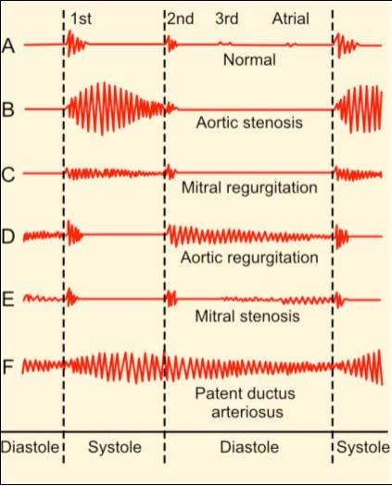
Design Report
Kai Lu
4
1. Introduction
1.1. Motivation
Murmurs are pathologic sounds that are produced by turbulent blood flow in the
heart. Detailed diagnoses of pathologic murmurs often require echocardiogram
procedures. Although the procedure is effective, it requires special equipment and
trained technicians to capture the necessary images and measurements. On the other
hand, heart murmurs can sometimes be detected by a physician using a standard
stethoscope during auscultation. This procedure is commonly performed during routine
check-ups. However, depending on the grade or severity of the murmur, the quality of
the stethoscope, and the training and skill of the physician, it can be difficult for a
physician to distinguish a murmur from a normal heartbeat. This design project aims to
assist physicians in detecting heart murmurs by analyzing cardiac signals in real time
during auscultation and reporting any detected abnormalities.
Figure 1. Ideal acoustic models for normal and abnormal heart sounds
[1]

Design Report
Kai Lu
5
1.2. Background
The task of designing a cardiac murmur detection algorithm has been previously
explored by several researchers in various academic groups. In general, the task can
be described as a pattern recognition problem using 1-dimensional medical data.
Pattern recognition typically involves two key steps: (1) Feature extraction and (2)
Classification. In feature extraction, one or more discriminative metrics are calculated
using the input data. These metrics are then used in classification to assign a specific
class label to the input data. For the problem of detecting cardiac murmurs, the
classification is binary – assigning either a normal or murmur label to the analyzed data.
The features commonly evaluated in literature belong to three distinct families:
(1) time-varying and time-frequency features, (2) perceptual features, and (3) fractal
features
[2]
. Time-varying and time-frequency features are based on different analyses
of the signal’s frequency spectrum and include operations such as the Short-time
Fourier Transform and Wavelet Transform. Perceptual features are calculated based on
the observation that a human’s perception of sound frequencies follows a logarithmic
instead of a linear curve. The most popular perceptual feature is the Mel-Frequency
Cepstral Coefficients of the signal. Lastly, fractal features involve the estimation of
complexity and/or chaos of a signal using measures such as the Hurst Exponent and
the Correlation Dimension.
The classification scheme can be selected independently from the features
calculated from the data. In general, classifiers can be grouped as either parametric or
non-parametric. Parametric models are often used when a specific mathematical form
can be estimated from the dataset. Examples of parametric classifiers include Support
Vector Machines and Maximum Likelihood Estimation. Non-parametric models are
typically used when the relationship between the input data and their respective classes
cannot be simply represented or are not well understood. Examples of non-parametric
models include K-Nearest Neighbor, Neural Networks, and Hidden Markov Models.

Design Report
Kai Lu
6
1.3. Challenges and Constraints
Although various features and classification approaches have been successfully
developed and tested, the performance of the algorithms depends highly on the specific
training and evaluation data sets. Pattern recognition in medical diagnostics often
suffers from a lack of data, particularly in comparison to the problems being solved in
non-medical fields such as voice recognition in audio recordings or face detection in
images. The lack of data is partly due to patient confidentiality but is also caused by the
limited number of available ground truth datasets. Trained physicians and technicians
are often needed to generate accurate ground truth annotations. In comparison, almost
any individual is capable of labeling faces in image or the words that are being spoken
in a recording.
In addition to robustly handling small data sets, there are several hardware and
software constraints related to the implementation of the detection algorithm on an
FPGA system. The memory constraint is the most significant challenge. The Altera DE2
development board includes 8 MB SDRAM, 512 KB SRAM, and 4 MB Flash memory.
The designed algorithm and user interface must be memory-efficient to fit within these
limits. In addition, computational efficiency is also an important factor. Many features
require several matrix operations to be computed on the input data. These must be
computed relatively quickly to reduce the analysis time on the system.

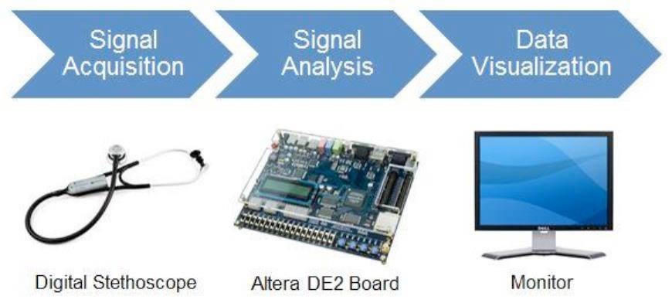
Design Report
Kai Lu
7
2. System Design
Figure 2. System Overview
The system hardware is composed of three core components: (1) A commercial
digital stethoscope for signal acquisition, (2) the Altera DE2 development board for
[3]
signal analysis and user interface processing, and (3) A standard VGA-compatible
monitor for data visualization. The system design was divided into two phases: (1)
Development of the murmur detection algorithm and (2) Implementation on the FPGA.
2.1. Murmur Detection
2.1.1. Datasets
Training and evaluation data sets were obtained from the online “Classifying
Heart Sounds Challenge” sponsored by PASCAL
[4]
. The challenge provides two
anonymous and publicly available datasets of acoustic heart signals: (1) Dataset A –
generated from the commercially available iStethoscope Pro iPhone app and (2)
Dataset B – generated from a digital stethoscope DigiScope being tested in clinical
trials. Because of the poor and inconsistent quality of Dataset A, only Dataset B was
used for this project.

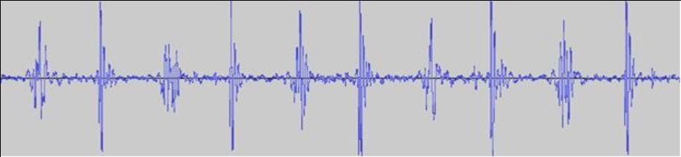
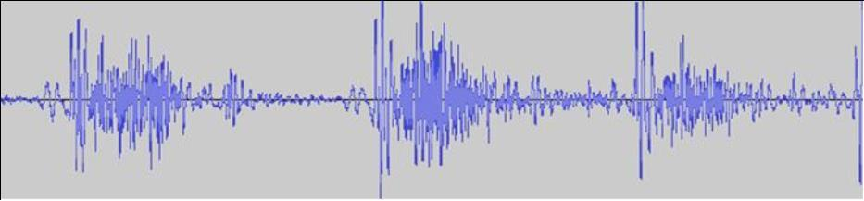
Design Report
Kai Lu
8
Dataset B contains 4 ground truth classifications of heart signal data and 1
unlabeled evaluation set. The classifications are as follows: normal, murmur, extra
systole, and artifact (recordings with excessive noise or other background sounds). Only
the normal and murmur ground truth sets were used for training and evaluation. Any
extra systole (extra heart sound) or noisy signal would be ideally classified as a murmur
by the detection algorithm. From the normal and murmur training sets and the single
evaluation set, noisy recordings were manually removed, resulting in a final dataset
count of 149 training recordings (83 normal, 66 murmur) and 117 evaluation recordings.
Figure 3. Example Waveform from Normal Dataset
(170_1307970562729_C.wav)
Figure 4. Example Waveform from Murmur Dataset
(248_1309201683806_C.wav)
2.1.2. Feature Extraction
The feature extraction step of the detection algorithm calculates the Low Energy
Rate [5], a single scalar value to be used as the discriminating parameter during
classification. The Low Energy Rate of a heart signal is defined as the fraction of the
signal that is below its root mean square (RMS) value. The RMS value for a signal x is:

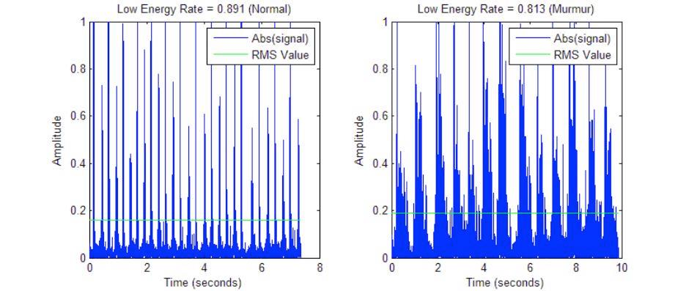
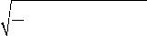
Design Report
Kai Lu
9
XRMS
=
1n (x1
2
+ x2
2
+!+ xn
2
)
Figure 5. RMS Equation
where x is the i sample of signal x (1 indexed). The Low Energy Rate for a signal is
i th
between 0 and 1.
Figure 6. Low Energy Rate Visualization from Example Waveforms
Figure 6 shows a visualization of the Low Energy Rate for a normal (left) and
murmur (right) waveform. The absolute value of each signal is used to compare against
the RMS value when calculating the fraction of data that is below the RMS. The intuition
behind this measure is that murmur heart sounds are frequently more turbulent and
contain higher amplitude events than normal, which results in smaller Low Energy
Rates. Calculations of the Low Energy Rate on both the training and evaluation
datasets were implemented using MATLAB.
2.1.3. Classification
After the Low Energy Rates were calculated for each waveform in the normal and
murmur ground truth training sets, a support vector machine was trained in MATLAB

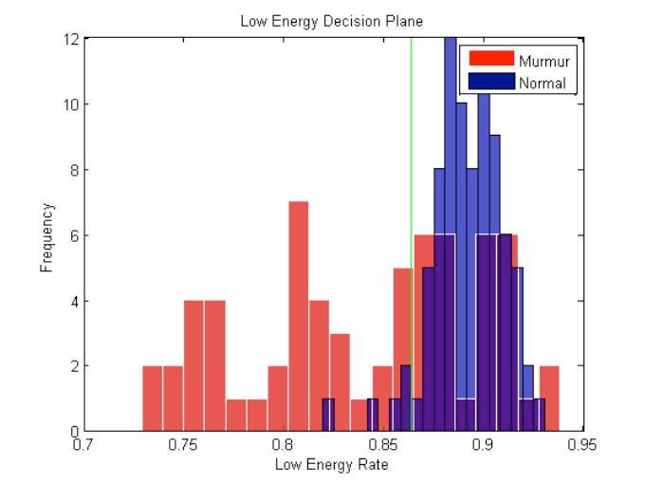
Design Report
Kai Lu
10
using the data. The function ‘svmtrain’ outputs an SVM model that describes an
optimized decision plane (or decision line for this specific project) through support
vectors and bias/scaling data. Using the training data, the optimal decision boundary
was computed to be a Low Energy Rate of 0.8633. For classification of the evaluation
set, signal Low Energy Rates > 0.8633 are classified as normal and Low Energy Rates
≤ 0.8633 are classified as murmurs.
Figure 7. SVM Decision Plane for Training Data
Figure 7 shows a histogram of the Low Energy Rates calculated from the training
datasets. The green vertical line indicates the decision plane output by the SVM. As the
data shows, the feature space is not completely separable and a degree of classification
error will occur on both the training and evaluation sets. The specific performance of this
algorithm is described in the next section.
2.1.4. Performance
Three metrics were used to evaluate the performance of the algorithm: (1)
Accuracy, (2) Sensitivity, and (3) Specificity. These measures are defined as follows:

Design Report
Kai Lu
11
TP +TN
Accurary=
TP +TN + FP + FN
TP
Sensentivity =
TP + FN
TN
Specificity =
TN + FP
Figure 8. Evaluation Metrics
where TP/FP are the number of true/false positives and TN/FN are the number of
true/false negatives. A positive identification refers to a murmur classification, while a
negative refers to a normal classification. The accuracy describes the overall accuracy
of the system, measuring how many classifications the algorithm correctly labeled out of
the total number of classifications assigned. Sensitivity is a measure of how well the
system detects and classifies murmurs. Similarly, specificity is a measure of how well
the system detects and classifies normal signals.
There is always a trade-off between the sensitivity and specificity of a system.
For example, if the decision plane was set to 1. All analyzed signals would be
categorized as murmurs, which results in a perfect sensitivity of 1 but a poor specificity
of 0. On the other hand, if the decision plane was set to 0. All signals would be
classified as normal, which results in a poor sensitivity of 0 and a perfect specificity of 1.
This trade-off for a specific system is typically summarized as a receiver operating
characteristic (ROC) curve.
Figure 9 shows the ROC curve for the implementation of the murmur detection
algorithm and its evaluation using the evaluation dataset. The y-axis shows the true
positive rate (sensitivity), while the x-axis shows the false positive rate (1 – specificity).
The points along the curve were obtained by incrementally adjusting the decision plane
away from the optimal boundary output by the SVM. Each point on the plot represents a
sensitivity/specificity performance combination at which the system can operate.

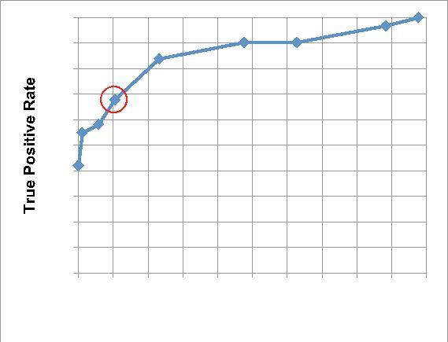
Design Report
Kai Lu
12
1
0.9
0.8
0.7
0.6
0.5
0.4
0.3
0.2
0.1
0
0 0.1 0.2 0.3 0.4 0.5 0.6 0.7 0.8 0.9 1
False Positive Rate
Figure 9. System ROC Curve
The point circled in red represents the performance achieved using the SVM decision
boundary. The performance metrics at this operating point are: Accuracy: 83.76%,
Sensitivity: 67.74%, and Specificity: 89.53%. Although this point was calculated to be
optimal by the SVM, diagnostic systems are typically tuned to operate at a higher
sensitivity to better detect diseases or abnormalities. Typically, physicians and patients
would rather err on the side of caution and have the system output more false positives
rather than false negatives.
2.1.5. Alternative Designs
Several feature vectors and their combinations were tested in the process of
identifying a suitable metric for implementation. These features include: spectrogram
volume, spectrogram shape, fractal dimension, signal entropy, signal brightness, MFCC
values, dynamic time warp matching, and others. None of these features or any tested
combinations of them resulted in better system performance than the Low Energy Rate
parameter. Adaptive boosting (AdaBoost) was also applied to each of these weak
classifiers using support vector machines to try to improve the system performance.
Although AdaBoost can arbitrarily minimize the error bound on the training dataset, the
results in the evaluation dataset did not improve.

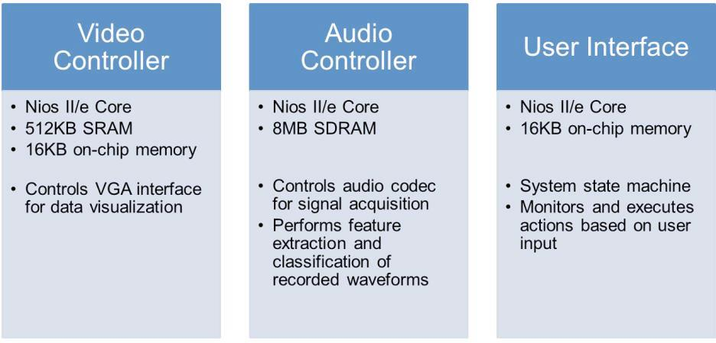
Design Report
Kai Lu
13
2.2. FPGA Implementation
Figure 10. FPGA Overview
The core FPGA design is based on implementations of three Nios II/e economy
cores, which execute compiled C programs that utilize the Nios II hardware abstraction
layer (HAL) API. The HAL provides a simple device driver interface to control external
components on the Altera DE2 development board. Using Nios II cores and HAL allows
for rapid development of robust and complex system logic with a potential trade-off in
system performance and memory utilization. The final design synthesis uses
7,263/33,216 (22%) total logic elements, 3812 registers, and 389,248/483,840 (80%)
total memory bits.
2.2.1. Video Controller
The Nios II core in the video controller is configured to use the University
Program (UP) – Video IP Suite, which offers basic functionality for driving output to a
VGA interface. The controller supports simultaneous character and pixel display by
using an alpha blender to combine two video streams into a single output to the
hardware VGA controller. ASCII characters (8x8 pixels large) are supported in
monochrome format and can only appear white on a transparent background. Pixel data

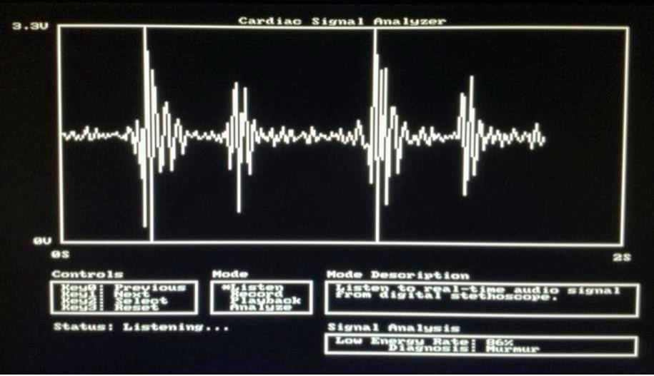
Design Report
Kai Lu
14
is represented in RGB but can only be output to a 320 x 240 resolution buffer, reducing
the standard VGA resolution in ½ in both dimensions. Character data is stored in on-
chip memory referencing ASCII bitmaps. Pixel data is stored in a buffer located in the
512KB external SRAM.
The video controller updates the display on start-up and subsequently only when
data is received from the audio or user interface controllers. When waveform data is
received from the audio controller, the pixel buffer is updated to draw a line on the on-
screen plot from the last recorded data point to the new point. The visual plot has a
resolution of 250 x 128 pixels. Once the plot is full, the video controller logic clears the
screen to prepare for the arrival of new data. The video controller is also responsible for
displaying information about the user controls, system mode, mode descriptions,
analysis results, and system status. Figure 11 shows an image of the controller’s VGA
output.
Figure 11. Screen Shot of Video Controller Output

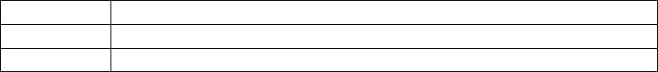
Design Report
Kai Lu
15
2.2.2. Audio Controller
The audio controller acquires waveform data by sampling the analog signal from
the digital stethoscope using the Wolfson WM8731 audio codec. The data is stored on
the external 8MB SDRAM memory. The codec is configured to output 16 bit data at a
sampling rate of 32 kHz using the UP – Audio device. However, Altera recommends
implementing the device on a Nios II standard or fast processor in order to ensure that
HAL driver functions will be able to read from the FIFO buffer at an appropriate rate.
These processors are too large to implement in the same FPGA design as the video
and user interface controllers. Therefore, the audio controller logic was developed to
sample the FIFO buffer at roughly 8 kHz. Although the lower sampling frequency has
adverse effects on voice recordings which range from 20 Hz – 20 kHz, internal body
sounds are much lower in frequency, with major components that are much less than 1
kHz. Thus, the integrity of the acquired audio signal will not affect signal analysis.
In addition to signal acquisition, the audio controller is responsible for performing
feature extraction and classification for the murmur detection algorithm. For
computational efficiency, no floating point operations are used when calculating the Low
Energy Rate. Once the feature is calculated and classified, the results are sent to the
video controller for visualization. Data is also sent to the video controller when
performing signal acquisition. Because the pixel buffer has limited resolution, the
acquired signal is sub-sampled for visual representation.
2.2.3. User Interface
The user interface controller contains the state machine of the system and
monitors pushbutton activity to respond to user actions. It also controls other basic I/O
on the development board, such as the green and red LEDs and switches. The user
interacts with the system by using the four pushbuttons KEY0 – KEY3 to change and
select the mode of operation. Figure 12 provides a summary of each system mode.
Mode
Listen
Record
Description
Listen to real-time audio signal from digital stethoscope.
Record audio signal and store in memory for future

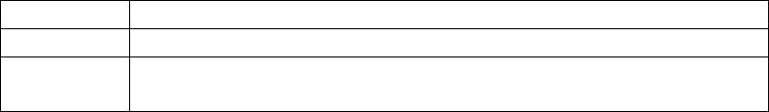
Design Report
Kai Lu
playback or analysis.
16
Playback Playback the last recorded signal.
Analyze Analyze the last recorded signal. The Low Energy Rate
and murmur diagnosis are reported.
Figure 12. System Modes
The user interface is also responsible for signaling the other controllers when a state
change or pushbutton event occurs.
2.2.4. Inter-processor Communication
Data and signals must be passed and shared between one controller and
another. This inter-processor communication requires synchronization to safely handle
the concurrency. Each controller uses Altera hardware mutex devices for multiprocessor
coordination. These mutexes are locked before a core accesses shared resources and
unlocked after it is finished operating on them. Because the amount of space required
for the shared resources is minimal, they are implemented as Parallel I/O ports for
convenient access. If larger segments of memory are needed, the resources could be
implemented using on-chip RAM memory instead.

Design Report
Kai Lu
17
3. Summary and Conclusions
An FPGA-based platform was developed for computer-aided diagnosis of cardiac
murmurs. Acoustic heart signals are captured and analyzed in real-time with
visualization on a VGA-compatible monitor for reporting. A new algorithm for murmur
detection was tested and evaluated in MATLAB and implemented on an Altera Cyclone
II FPGA using a multi-core Nios II system. The resulting system is capable of aiding
diagnosis by detecting murmurs with 83.76% accuracy.
The murmur detection algorithm that performed the best during preliminary testing
was a relatively simple feature, the Low Energy Rate. Calculations of the Low Energy
Rate do not require any complex matrix operations unlike the FFT operator. The system
was initially proposed to be implemented on an FPGA in order to take advantage of
hardware parallelization and efficiency for more complicated feature calculations.
However, the results of this project indicate that the extra processing power is
unnecessary due to the simplicity of the low energy feature. Instead, a more compact
microcontroller-based system can be developed instead for lower energy utilization and
a smaller device footprint, as long as VGA support is not necessary.

Design Report
Kai Lu
18
4. References
[1] "Heart Murmur." Wikipedia. Wikimedia Foundation, 12 Sept. 2012. Web.
[2] Delgado-Trejos E et. Al. Digital auscultation analysis for heart murmur detection.
Annals of Biomedical Engineering 2009;37:337-53.
[3] Thinklabs ds32a+ Electronic Stethoscope. <http://www.thinklabsmedical.com/>.
[4] Bentley, P. and Nordehn, G. and Coimbra, M. and Mannor, S. “The PASCAL
Classifying Heart Sounds Challenge 2011”.
<http://www.peterjbentley.com/heartchallenge/index.html>.
[5] G. Tzanetakis and P. Cook "Musical Genre Classification of Audio Signals", IEEE
Transactions on Speech and Audio Processing , 10(5), July 2002.
5. Resources
• Nios II Software Handbook:
http://www.altera.com/literature/hb/nios2/n2sw_nii5v2.pdf
• Altera University Program IP Cores:
http://www.altera.com/education/univ/materials/comp_org/ip-cores/unv-ip-
cores.html
• Support Vector Machines: http://www.mathworks.com/help/bioinfo/ug/support-
vector-machines-svm.html
• ECE 5760 Course Website: http://people.ece.cornell.edu/land/courses/ece5760/

